Kancharla Brundarika
Insert Data:
use BookStoreDB
switched to db BookStoreDB
db.books.insertMany([
{ bookId:101, title:"Mastering Java", author:"James Carter", category:"Programming", price:850, stock:20, publishedYear:2022, rating:4.5, isAvailable:true, tags:["Java","Backend","OOP"], publisher:{name:"TechBooks",city:"Bangalore"} },
{ bookId:102, title:"MongoDB Basics", author:"Ravi Kumar", category:"Database", price:650, stock:15, publishedYear:2021, rating:4.2, isAvailable:true, tags:["MongoDB","NoSQL"], publisher:{name:"DBBooks",city:"Hyderabad"} },
{ bookId:103, title:"Python for Beginners", author:"Anita Sharma", category:"Programming", price:500, stock:25, publishedYear:2020, rating:4.3, isAvailable:true, tags:["Python","Coding"], publisher:{name:"LearnBooks",city:"Delhi"} },
{ bookId:104, title:"Advanced SQL", author:"Rahul Mehta", category:"Database", price:700, stock:10, publishedYear:2019, rating:4.1, isAvailable:true, tags:["SQL","Database"], publisher:{name:"TechBooks",city:"Mumbai"} },
{ bookId:105, title:"Web Development Guide", author:"Kiran Patel", category:"Web", price:900, stock:8, publishedYear:2023, rating:4.6, isAvailable:true, tags:["HTML","CSS","JS"], publisher:{name:"WebBooks",city:"Pune"} },
{ bookId:106, title:"Data Structures", author:"Vikram Singh", category:"Programming", price:750, stock:12, publishedYear:2021, rating:4.4, isAvailable:true, tags:["DSA","Algorithms"], publisher:{name:"AlgoBooks",city:"Chennai"} },
{ bookId:107, title:"Machine Learning Basics", author:"Suresh Reddy", category:"AI", price:950, stock:7, publishedYear:2022, rating:4.7, isAvailable:true, tags:["ML","AI"], publisher:{name:"AI Books",city:"Bangalore"} },
{ bookId:108, title:"React JS Guide", author:"Naveen Kumar", category:"Web", price:600, stock:18, publishedYear:2021, rating:4.3, isAvailable:true, tags:["React","Frontend"], publisher:{name:"WebBooks",city:"Hyderabad"} },
{ bookId:109, title:"Node JS Complete", author:"Amit Verma", category:"Programming", price:800, stock:5, publishedYear:2020, rating:4.2, isAvailable:true, tags:["Node","Backend"], publisher:{name:"TechBooks",city:"Delhi"} },
{ bookId:110, title:"MongoDB Advanced", author:"Ramesh Gupta", category:"Database", price:880, stock:9, publishedYear:2023, rating:4.6, isAvailable:true, tags:["MongoDB","NoSQL"], publisher:{name:"DBBooks",city:"Chennai"} }
]);
{
acknowledged: true,
insertedIds: {
'0': ObjectId('69d60fe6ed9bf5257ecd6d27'),
'1': ObjectId('69d60fe6ed9bf5257ecd6d28'),
'2': ObjectId('69d60fe6ed9bf5257ecd6d29'),
'3': ObjectId('69d60fe6ed9bf5257ecd6d2a'),
'4': ObjectId('69d60fe6ed9bf5257ecd6d2b'),
'5': ObjectId('69d60fe6ed9bf5257ecd6d2c'),
'6': ObjectId('69d60fe6ed9bf5257ecd6d2d'),
'7': ObjectId('69d60fe6ed9bf5257ecd6d2e'),
'8': ObjectId('69d60fe6ed9bf5257ecd6d2f'),
'9': ObjectId('69d60fe6ed9bf5257ecd6d30')
}
}
db.customers.insertMany([
{ customerId:1, name:"Brunda", email:"brunda@gmail.com", city:"Chennai", age:22, membershipType:"Silver", isActive:true, interests:["MongoDB","Programming"] },
{ customerId:2, name:"Krithi", email:"krithi@gmail.com", city:"Hyderabad", age:23, membershipType:"Gold", isActive:true, interests:["Java","Web"] },
{ customerId:3, name:"Pravalika", email:"pravalika@gmail.com", city:"Bangalore", age:24, membershipType:"Silver", isActive:true, interests:["Python","AI"] },
{ customerId:4, name:"Kumar", email:"kumar@gmail.com", city:"Chennai", age:25, membershipType:"Gold", isActive:true, interests:["Database","MongoDB"] },
{ customerId:5, name:"Hari", email:"hari@gmail.com", city:"Delhi", age:26, membershipType:"Silver", isActive:false, interests:["NodeJS","Backend"] },
{ customerId:6, name:"Divya", email:"divya@gmail.com", city:"Mumbai", age:23, membershipType:"Gold", isActive:true, interests:["React","Frontend"] },
{ customerId:7, name:"Sowmya", email:"sowmya@gmail.com", city:"Chennai", age:22, membershipType:"Silver", isActive:true, interests:["Java","OOP"] },
{ customerId:8, name:"Aishu", email:"aishu@gmail.com", city:"Hyderabad", age:21, membershipType:"Gold", isActive:true, interests:["Machine Learning","AI"] },
{ customerId:9, name:"Puja", email:"puja@gmail.com", city:"Bangalore", age:24, membershipType:"Silver", isActive:true, interests:["Web","CSS"] },
{ customerId:10, name:"Mrudhula", email:"mrudhula@gmail.com", city:"Chennai", age:23, membershipType:"Gold", isActive:true, interests:["MongoDB","Database"] }
]);
{
acknowledged: true,
insertedIds: {
'0': ObjectId('69d61174ed9bf5257ecd6d31'),
'1': ObjectId('69d61174ed9bf5257ecd6d32'),
'2': ObjectId('69d61174ed9bf5257ecd6d33'),
'3': ObjectId('69d61174ed9bf5257ecd6d34'),
'4': ObjectId('69d61174ed9bf5257ecd6d35'),
'5': ObjectId('69d61174ed9bf5257ecd6d36'),
'6': ObjectId('69d61174ed9bf5257ecd6d37'),
'7': ObjectId('69d61174ed9bf5257ecd6d38'),
'8': ObjectId('69d61174ed9bf5257ecd6d39'),
'9': ObjectId('69d61174ed9bf5257ecd6d3a')
}
}
__________________________________________________________________________________________
db.orders.insertMany([
{ orderId:1, customerId:1, bookId:101, quantity:2, totalAmount:1700, orderDate:new Date("2024-01-10"), paymentMode:"UPI", status:"Delivered" },
{ orderId:2, customerId:2, bookId:102, quantity:1, totalAmount:650, orderDate:new Date("2024-01-12"), paymentMode:"Credit Card", status:"Pending" },
{ orderId:3, customerId:3, bookId:103, quantity:3, totalAmount:1500, orderDate:new Date("2024-01-15"), paymentMode:"Cash", status:"Delivered" },
{ orderId:4, customerId:4, bookId:104, quantity:1, totalAmount:700, orderDate:new Date("2024-01-18"), paymentMode:"UPI", status:"Pending" },
{ orderId:5, customerId:5, bookId:105, quantity:2, totalAmount:1800, orderDate:new Date("2024-01-20"), paymentMode:"Debit Card", status:"Cancelled" },
{ orderId:6, customerId:6, bookId:106, quantity:1, totalAmount:750, orderDate:new Date("2024-01-22"), paymentMode:"UPI", status:"Delivered" },
{ orderId:7, customerId:7, bookId:107, quantity:1, totalAmount:950, orderDate:new Date("2024-01-25"), paymentMode:"Credit Card", status:"Pending" },
{ orderId:8, customerId:8, bookId:108, quantity:2, totalAmount:1200, orderDate:new Date("2024-01-28"), paymentMode:"UPI", status:"Delivered" },
{ orderId:9, customerId:9, bookId:109, quantity:1, totalAmount:800, orderDate:new Date("2024-02-01"), paymentMode:"Cash", status:"Cancelled" },
{ orderId:10, customerId:10, bookId:110, quantity:2, totalAmount:1760, orderDate:new Date("2024-02-05"), paymentMode:"UPI", status:"Pending" }
]);
{
acknowledged: true,
insertedIds: {
'0': ObjectId('69d61196ed9bf5257ecd6d3b'),
'1': ObjectId('69d61196ed9bf5257ecd6d3c'),
'2': ObjectId('69d61196ed9bf5257ecd6d3d'),
'3': ObjectId('69d61196ed9bf5257ecd6d3e'),
'4': ObjectId('69d61196ed9bf5257ecd6d3f'),
'5': ObjectId('69d61196ed9bf5257ecd6d40'),
'6': ObjectId('69d61196ed9bf5257ecd6d41'),
'7': ObjectId('69d61196ed9bf5257ecd6d42'),
'8': ObjectId('69d61196ed9bf5257ecd6d43'),
'9': ObjectId('69d61196ed9bf5257ecd6d44')
}
}

Part 3: Basic CRUD Assignments
CREATE Operations
Task 6
Insert one new book document into the books collection.
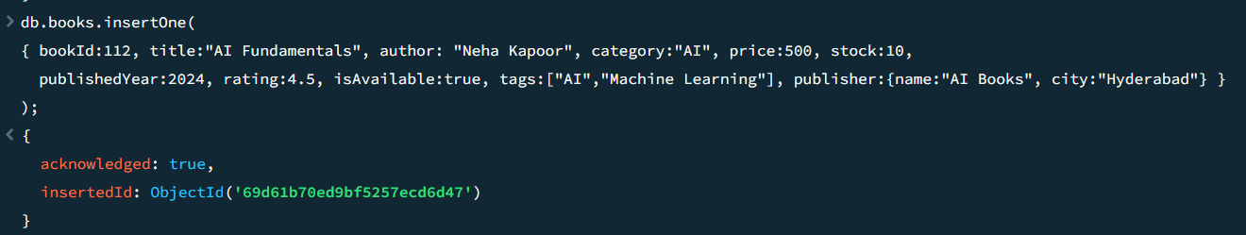
Task 7
Insert one new customer document into the customers collection.
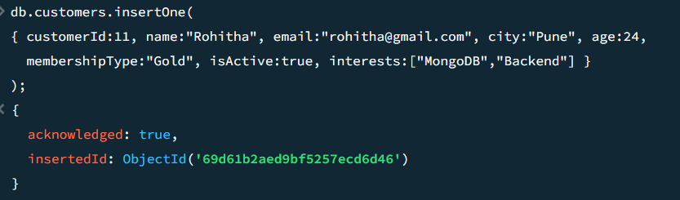
Task 8
Insert one new order document into the orders collection.
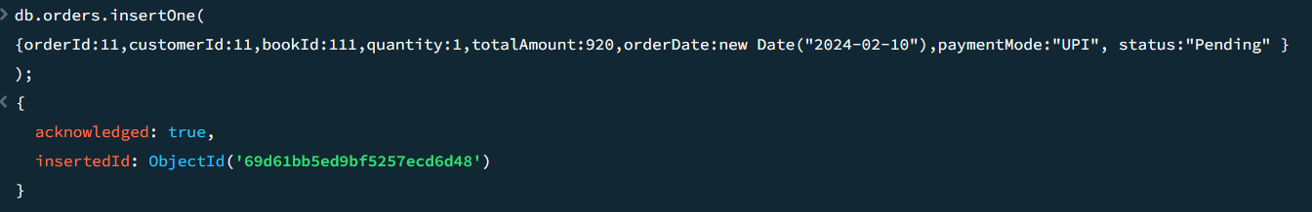
READ Operations
Task 9
Display all books.
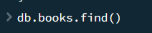
Task 10
Display all customers.
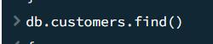
Task 11
Display all orders.
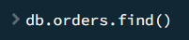
Task 12
Find only one book whose title is "Mastering Java".
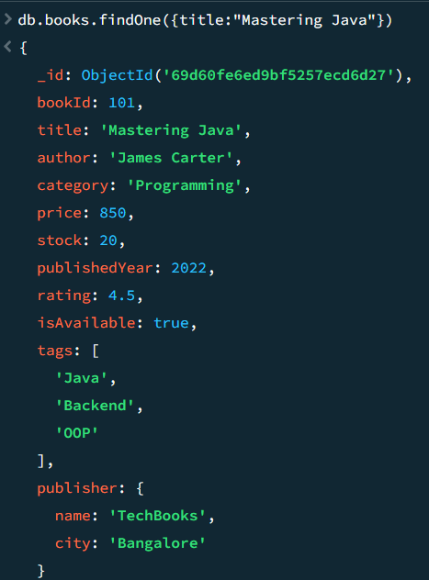
Task 13
Find all customers from "Chennai".
Task 14
Find all orders where payment mode is "UPI".

UPDATE Operations
Task 15
Update the price of a specific book.
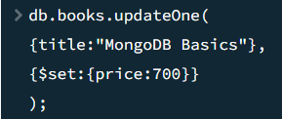
Task 16
Update the stock of a book after a sale.
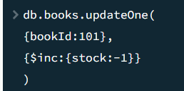
Task 17
Change a customer's membership type from "Silver" to "Gold".
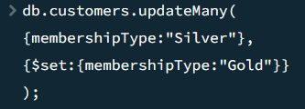
Task 18
Update the order status from "Pending" to "Delivered".
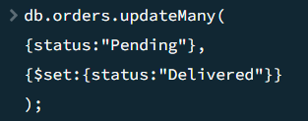
DELETE Operations
Task 19
Delete one book whose stock is 0.
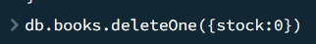
Task 20
Delete one inactive customer.
Task 21
Delete all orders with status "Cancelled".
Part 4: Comparison Operators Assignment
Use the books collection.
Task 22 – $eq
Find books whose category is exactly "Programming".
Task 23 – $ne
Find books whose category is not "Programming".
Task 24 – $gt
Find books whose price is greater than 700.
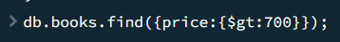
Task 25 – $gte
Find books whose rating is greater than or equal to 4.5.
Task 26 – $lt
Find books whose stock is less than 10.
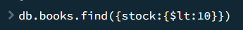
Task 27 – $lte
Find books published in or before 2020.
Task 28 – $in
Find books whose category is either "Programming" or "Database".
Task 29 – $nin
Find books whose category is not in "Programming" and "Database".
Part 5: Logical Operators Assignment
Task 30 – $and
Find books where:
- category is "Programming"
- price is greater than 500
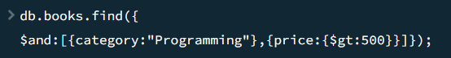
Task 31 – $or
Find books where:
- stock is less than 5
- or rating is greater than 4.7
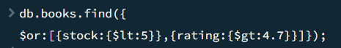
Task 32 – $not
Find books whose price is not greater than 1000.
Task 33 – $nor
Find books that are neither in "Programming" category nor have rating above 4.5.
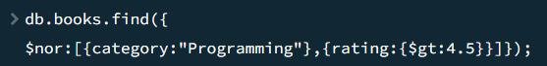
Part 6: Element Operators Assignment
Task 34 – $exists
Find books where the field publisher.city exists.
Task 35 – $type
Find documents where price is stored as a numeric type.
Part 7: Array Operators Assignment
Use the books and customers collections.
Task 36 – $all
Find books whose tags contain both "Java" and "OOP".
Task 37 – $size
Find customers who have exactly 2 interests.
Task 38 – $elemMatch
Find books where tags contains a matching value from a given condition.
Task 39
Find customers interested in "MongoDB".
Part 8: Evaluation Operators Assignment
Task 40 – $regex
Find books whose title starts with "M".

Task 41 – $regex

Find customers whose email ends with "gmail.com".
Task 42 – $expr
Find books where price is greater than stock.
Part 9: Projection Assignment
Task 43
Display only:
- title
- author
- price
from the books collection.
Task 44
Display customer name and city only, excluding _id.
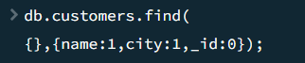
Task 45
Display orderId, customerId, and totalAmount only.
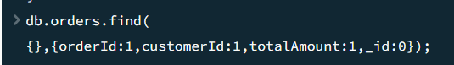
Part 10: Sorting Assignment
Task 46
Display books sorted by price in ascending order.
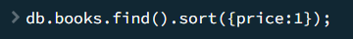
Task 47
Display books sorted by rating in descending order.
Task 48
Display customers sorted by age from highest to lowest.
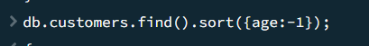
Task 49
Display orders sorted by order date from latest to oldest.
